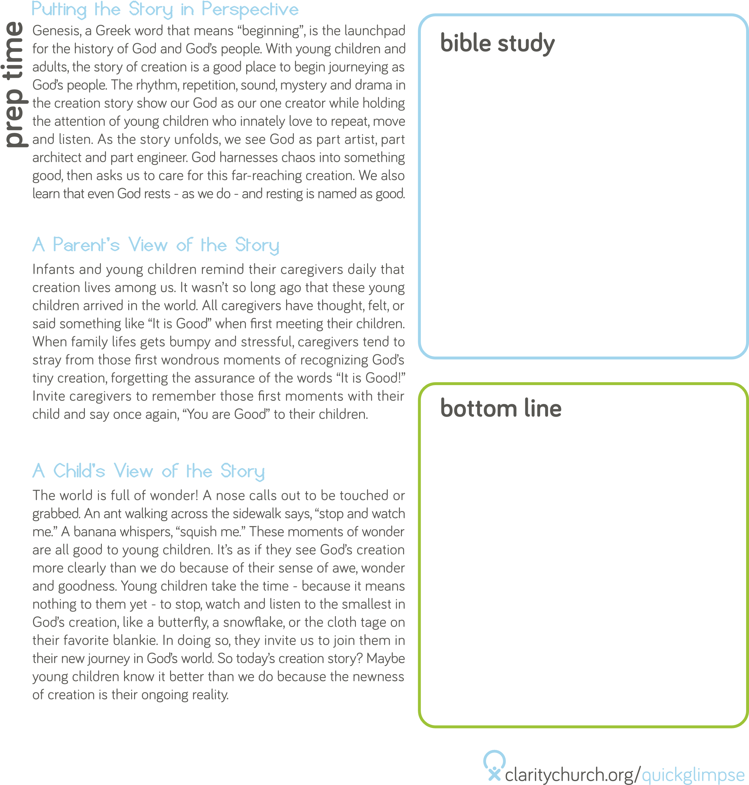

Many parents wait and wait for their children as Sarah and Abraham

did. They may wait for financial security or health insurance. Others

wait because of fertility issues. Some wait for the adoption agency

to call. And everyone waits for the child to arrive. No matter the

circumstances, waiting is an unavoidable part of becoming a

parent. After a child is born, the waiting days are far from over.

Parents may now wait for the day when they no longer pay for

formula, diapers, or monthly child care bills. Some wait with anxiety

for medical test results or a delayed developmental milestone, like

talking or walking. Today’s story can remind parents to trust in God,

themselves, and their community as they patiently wait for what

unfolds on their parenting journey.

Genesis 18:14

“Is anything too

wonderful for the Lord?

At the set time I will

return to you, in due

season, and Sarah shall

have a son.”

God made a promise and it came true!

In the eyes of a young child, what could be more normal than a

story about a baby? To young children, the entire universe may

consist of babies and their caregivers. What this story introduces

to young children is the idea of God’s promises. Keeping promises

began with God. The Bible is filled with stories of God making and

upholding promises. Keeping promises is a new concept to young

children. Someday they will learn to keep promises. A main source

of learning will come from trusted adults in their environment,

which includes you as the storyteller who shares about Abraham,

Sarah, and Isaac.

Abraham and Sarah are the first (but not the last) biblical parents

who must wait for their child. Their trust in God has been tested

by this span of time. Yet God keeps promises. In this case, God’s

promise is so outrageous that Sarah laughs at the impossibility of

the situation. As she laughs, her old husband wonders how this

can be. This story invites families to imagine waiting, laughter, and

babies experienced by a childless couple old enough to be greatgrandparents.

But the crux of today’s story is God’s kept promise to

Abraham that extends to us.

ACTIVITY

