June 25, 2017
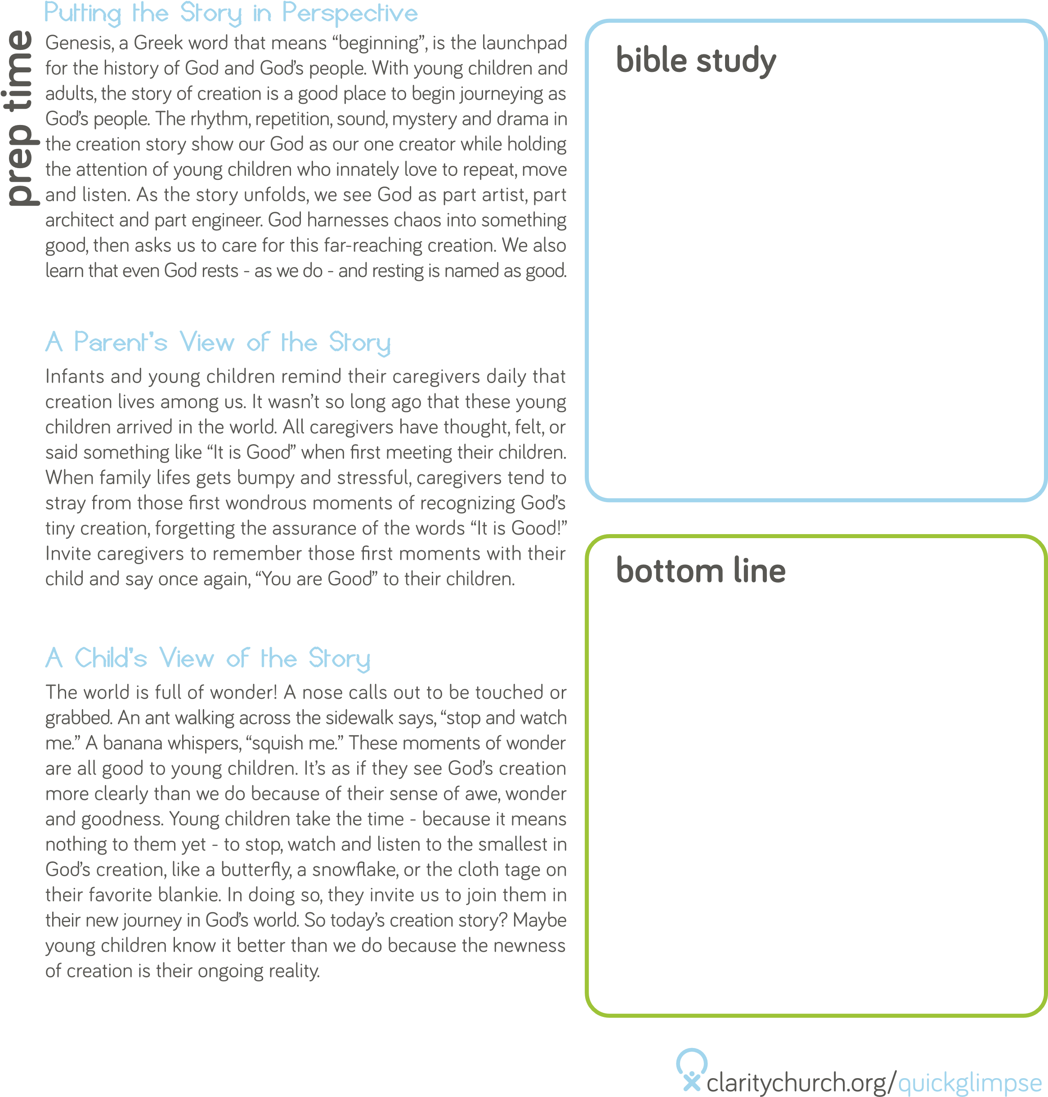
“Jesus then took the loaves, gave thanks, and distributed to those who were seated as much as they wanted. He did the same with the fish”
- John 6:11
God will provide for me and my family.
In today’s story, young children learn that Jesus cares for them just
like other loving adults do. They’ll also discover that the little boy
with the fish and bread shares! Young children hear about sharing
what they have, just like the little boy. Finally, Jesus blesses the
food in today’s story. Blessing and praying over food is something
many young children experience with their families. It’s also
something they see during worship when the pastor prays over holy
communion.
A parent’s view of this miracle will likely vary depending on their
situation. Some parents will see it from a place of struggling to
have enough food to feed their family. Others will never have
experienced food scarcity. All will realize that, while God is at work
in our everyday lives, God doesn’t usually multiply bread and fish
in front of our eyes. No matter their situation, parents can discover
that Jesus is teaching about how God cares for us by showing us
that we have more than enough, we never need to doubt God’s
love for us, and we can see miracles in our children.
The story of Jesus feeding the 5,000 appears in all four Gospels.
Jesus preaches. A crowd gathers. It grows late and the crowd is
hungry. There is no food. But a boy has two fish and five barley
loaves. Jesus takes these meager offerings and feeds the entire
crowd with twelve baskets left over. Jesus shows us in this story
that even the youngest or least likely to be able to help may assist
in God’s miracles.

ACTIVITY
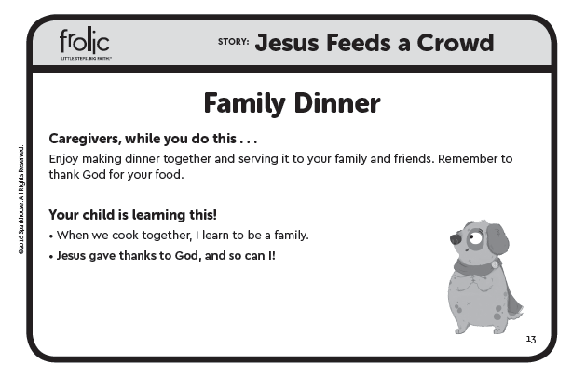

STORY: Jesus Is Born

Baby Bath Station

Caregivers, while you do this . . .

Enjoy time together as you bathe, dry, and dress the babies.

Your child is learning this!

• When I bathe the baby, I remember the things we do when I take a bath.
• Caring for a baby helps me develop empathy.

• When I bathe the baby, I remember that Jesus was born as a real baby.

13
claritychurch.org/quickglimpse

