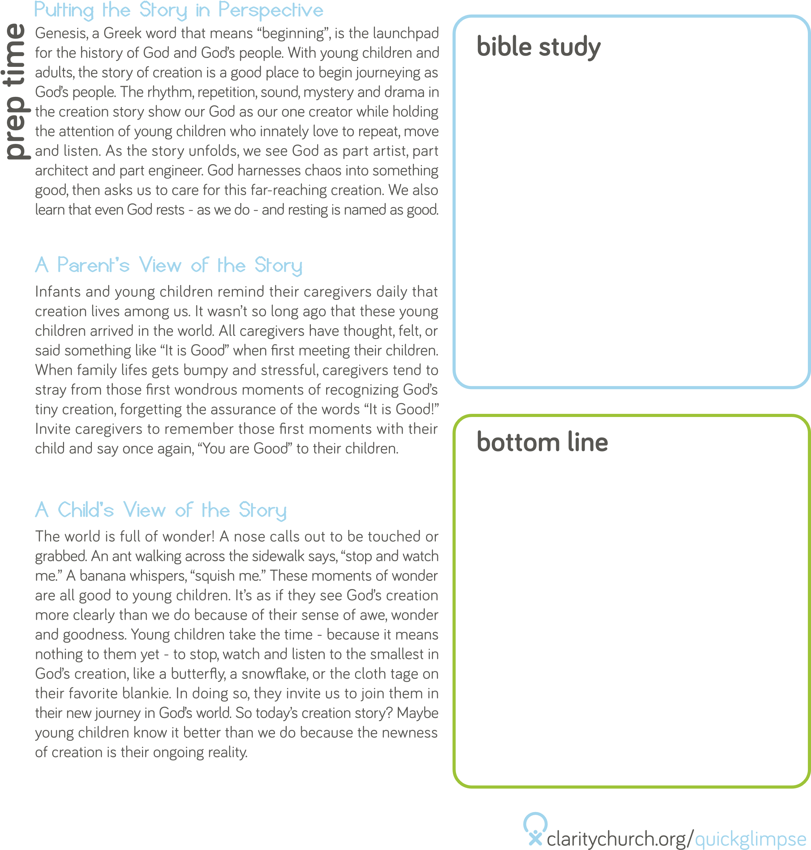

Caregivers and the broader culture may focus on how much little

ones take from us (sleep, time, energy, and other resources) or what

they cannot yet do. Parenting a little child is exhausting, demanding

work that requires constant attention. It is easy for parents to

wish this time away, longing for the days of daily showers or

spontaneous dinners. They also may think ahead to a time when

children will grow bigger so they can feed and dress themselves

and go to school. What often gets lost in the caregiver’s world

is what these little ones have to teach us. They are filled with big

lessons about faith and God’s love.

Mark 10: 14

“Let the little children come to me”

God loves us when we are big & when we are little.

Parents of infants hear, “She’s getting so big!” on a regular basis.

Toddlers may declare, “I am the mama and you are the baby!” as

they play. The infant and toddler years are filled with conversation

and imaginative play centered on dreams of getting bigger and

growing up. When children are old enough to start understanding

what it means to be “sooo big!” they may long to be bigger. When

we take the time to celebrate who they are in the present, we are

sharing the love of God with them. We can also teach them the

equal importance of dreaming big and noticing the little gifts of

each day.

Themes of big and little are seen throughout scripture. Little David

slays big Goliath. The little mustard seed grows into a big shrub.

But we also see Jesus calling us to have faith like a little child,

and welcoming the little children to come to him. This gives us a

window into how God loves us for who we are becoming as we

grow, even as God simultaneously loves us in the present. God sees

the gifts of who we are *now*, at every age and stage.

ACTIVITY

