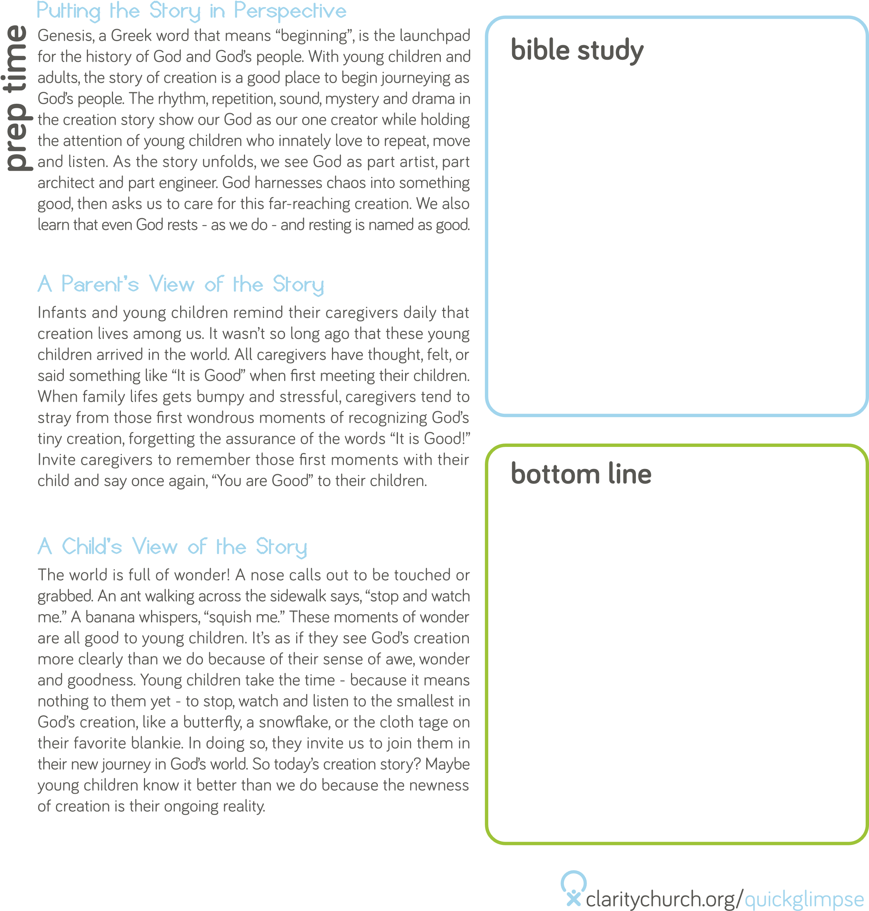

Psalm 139:3

“You search out my path and my lying down, and are acquainted with all my ways.”

God is with us everywhere

“Peekaboo! I see you!” Between the ages of 6-12 months, infants

develop the ability to remember that something exists even though they cannot see it. This concept is known as object permanence. Once it emerges, the joy of playing Hide and Seek begins. (So do the fears that come along with children not being able to find their parents.) Even after this awareness develops, children will still ask for help to find a favorite toy. “Where is my blankie?” “I can’t find my shoe!” Children are constantly losing things! But God is always able to find them and be with them no matter where they may be: at daycare, in the car, in their bedrooms, and even hiding in a fort!

Getting lost is one of our earliest fears. Being known is one of our

deepest desires. God knew us at the moment our child was placed

in our arms. God found us and called us to care for this miracle.

Through the day-to-day routines and through the highs and lows

our children bring us, God knows us, finds us, and carries us. This

session allows parents to receive two truths. First, God is always

with us as parents, no matter how lost we may feel. Second, God

will always be with our children, no matter where life takes them.

The Bible is filled with stories of God seeking out those who are

lost. Adam and Eve hide in the garden. Jonah runs away rather than

going to Nineveh. A woman sweeps and searches to find her lost

coin. One sheep is separated from the ninety-nine. The apostles

hide out in the upper room after Jesus’ death. The psalmist in this

lesson’s Bible verse reminds us of how intimately known we are by

God. There is nowhere we can go that God will not search for us

and find us. That is good news worth seeking and finding!

ACTIVITY

