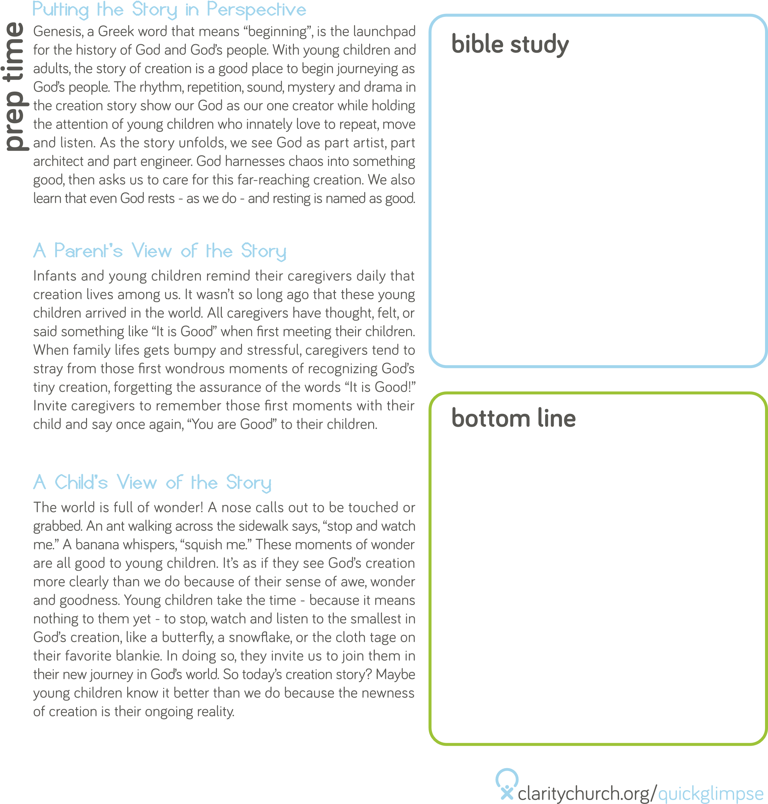

John 15:12

“This is my commandment, that you love one another as I have loved you.”

God is our friend and he sends us other friends to love and care for.

From the time we are born, we are created to be social. Newborns

can recognize human voices and sounds in their native language(s).

They show a strong preference for looking at human faces.

Young babies will grow to follow a trusted adult’s eye gaze and

imitate the adults around them. Studies show that children who

are raised in secure, loving environments grow up to have better

emotional control, stronger communication skills, and more helpful,

empathetic behavior toward others. These skills all contribute to

children being better able to make friends. Learning the social skills

we need to navigate future friendships is a long process that begins

early in life, starting with what we experience in our own families.

No matter who is in your social circle before you have children,

the reality is that parenting takes a toll on your ability to develop

and maintain adult friendships. Many parents find they are too

tired to interact with others. Some find it difficult to fit in time with

friends around a young child’s erratic and demanding schedule. As

Christians, we know that we are called to share one another’s joys

and burdens. Friendships can be a critical part of surviving the first

few years of parenting. Time together with other parents, whether

on playdates or in parent-only settings, is healthy for both adults

and children.

The Bible describes friendships as a life-giving source of strength and community. It also advises us to consider carefully whom we choose to be our friends. King David is helped by his friend

Jonathan. Ruth and Naomi are family, but share a deep, respectful

friendship. Jesus is friends with all his disciples, and Peter is

described as a close friend. After the death and resurrection of

Jesus, the gospel message is spread through friendships like the

one between Paul and Barnabas. The Bible also teaches us values

that help us make and keep friends. Being honest, caring, forgiving,

and patient are all keys to building Christian friendships.

ACTIVITY

