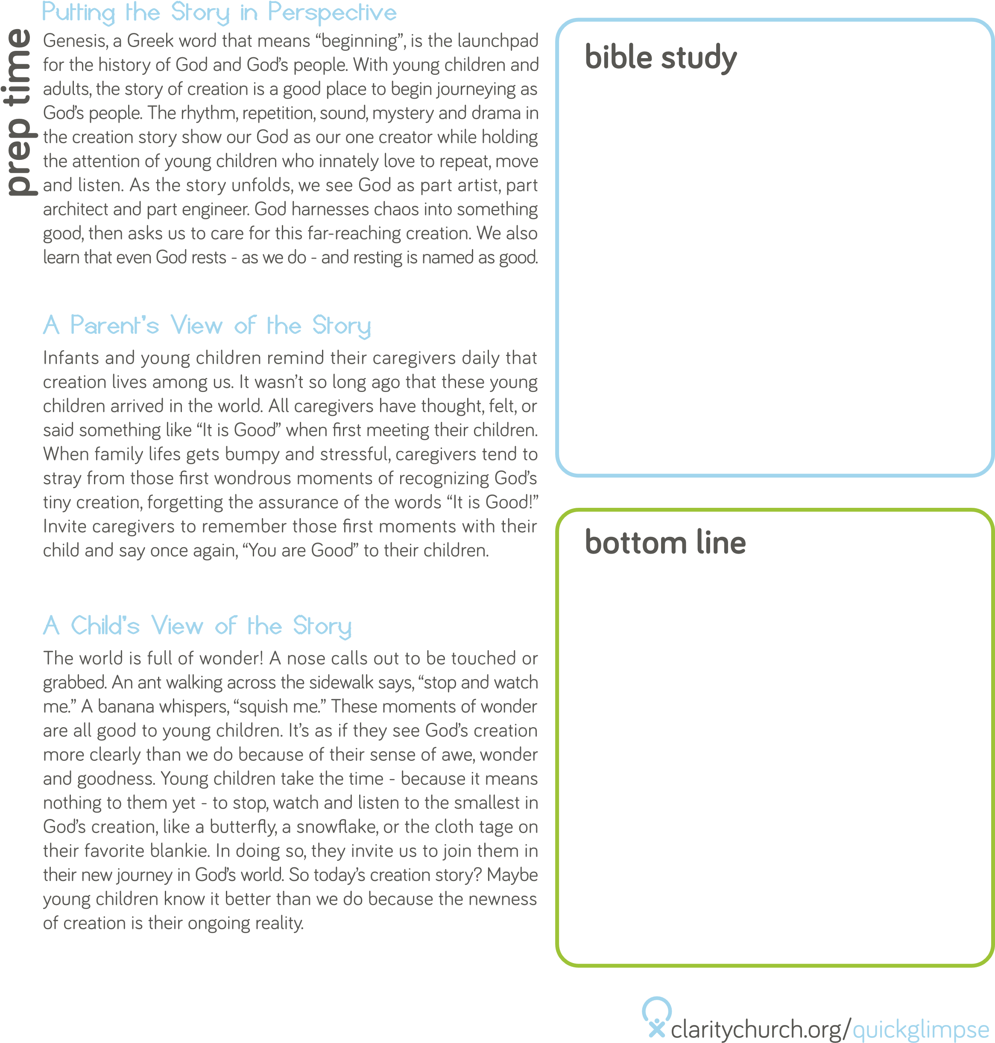

A young child is regularly being coached by adults to share with

others. The challenge with this request? Because of the emotional,

cognitive, and social skills required to share, young children

are not equipped to willingly share with others until well into

their preschool years. This means that sharing is very difficult for

young children! As toddlers learn about themselves as unique,

separate individuals, part of that individualization is owning things.

Giving something away that they feel ownership over may feel

like giving away part of themselves. Pairing an awareness of this

developmental truth with good models for sharing possessions and

sharing love is key to teaching about sharing during this tender

time of life.

Hebrews 13:16

“Do not neglect to do good and to share what you have, for such sacrifices are pleasing to God.”

God wants us to share with others, especially His love.

The act of sharing is a key part of the daily work of parenting.

Parents are sharing a part of themselves all the time. Pregnant

and nursing mothers are sharing their bodies. Adoptive parents

are sharing their time, resources, and love in order to form their

families. Families find they are sharing their space as the home fills

up with new baby supplies. Couple time and alone time must be

spared so that time is shared with the new baby. Throughout all

of these demands, parents are expected to set good examples of

how to share so that their children will grow up to be generous

and hospitable. With all of these demands, sharing can seem like a

burden, and the gifts of faithful sharing can be lost.

Scripture offers abundant examples of sharing. In the beginning, we

see God sharing creation with humans and asking us to care for it.

Joseph shared food with his brothers as part of their reconciliation.

An innkeeper in Bethlehem offered a stable as lodging for Mary

and Joseph. A little boy shared five loaves of bread and two fish

with Jesus. The book of Acts describes how the early Christian

community shared all their possessions as they lived together with

the common goal of spreading the good news of Jesus Christ.

ACTIVITY

